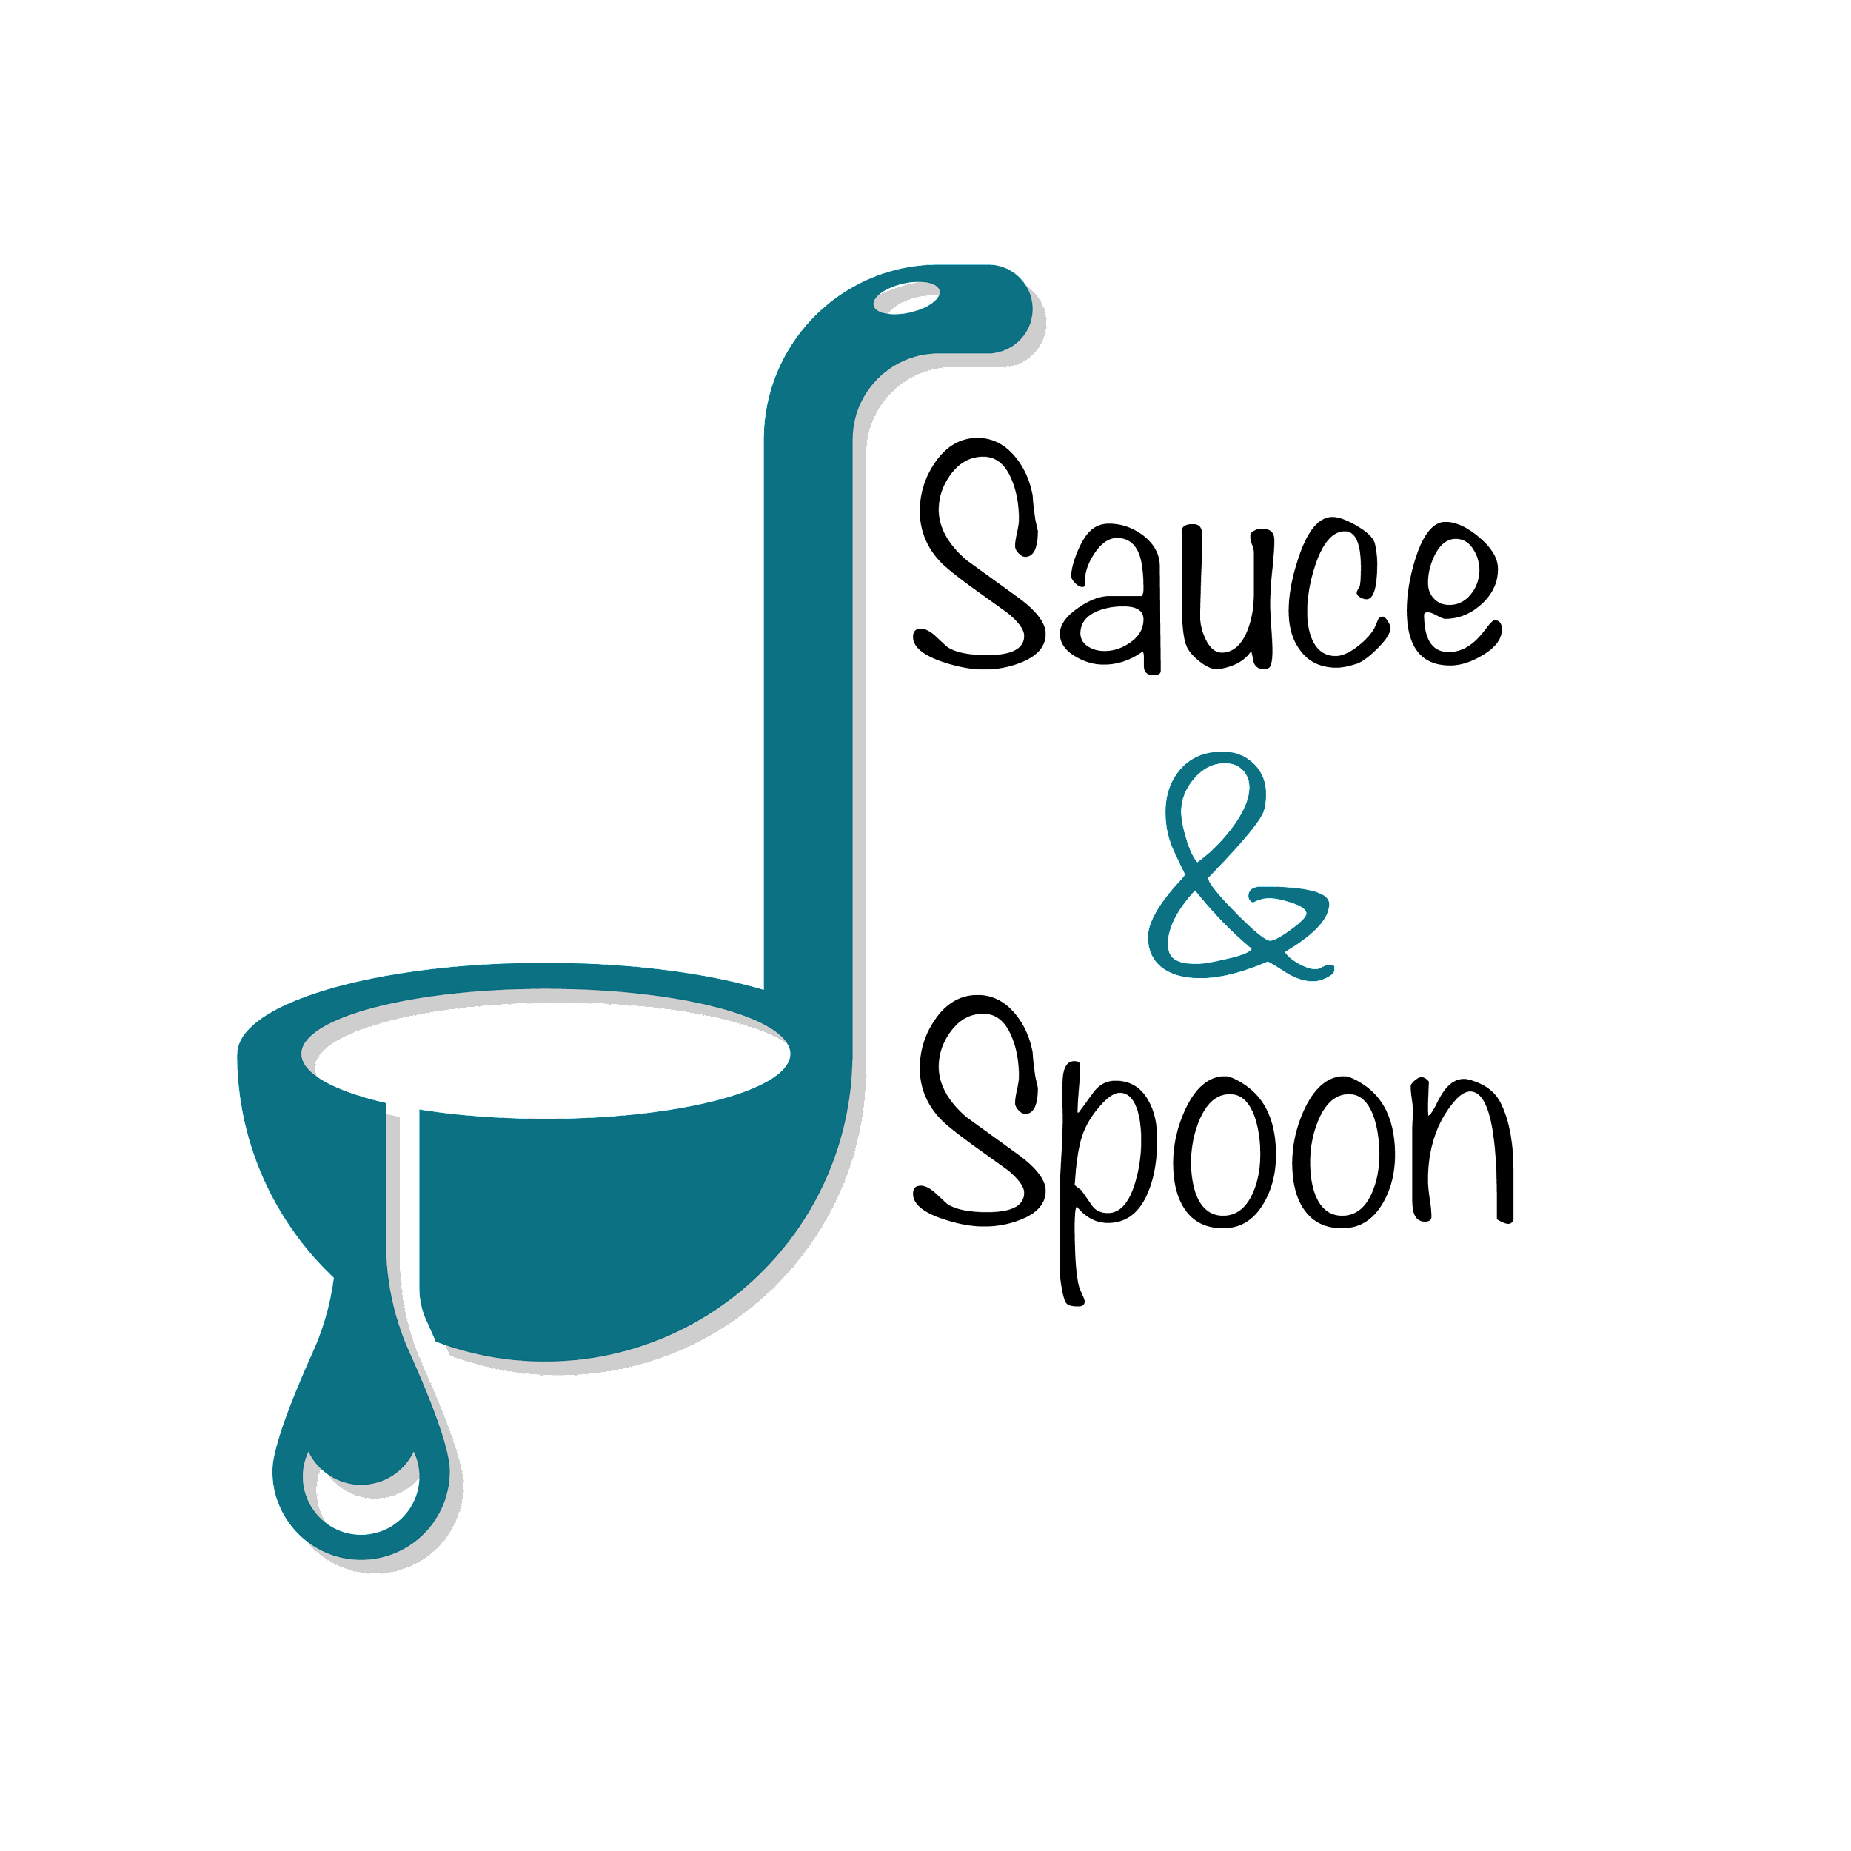

Project Charter: [**tabletop menu tablets**]

DATE: [10/09/23]

| **Project Summary** |
| --- |
| Sauce & Spoon would like to launch a pilot rollout of tabletop menu tablets at two of their restaurant locations, Sauce & Spoon North and Sauce & Spoon Downtown. That way, guests can place their orders on the tablets as soon as they arrive at the restaurant, rather than waiting for a server to attend to them, which has been an issue in the past. |

| **Project Goals** |
| --- |
| * increase of product mix * decrease of average table turn time by 30 minutes * Cut food waste by 25% * 15% increase appetizers sales * selling more specialty drinks * reallocate some of the payroll from our FOH budget to hire more cooks * increased average check value * Increase daily guest counts by 10% * improving the satisfaction of the kitchen staff * Decrease employee burnout and turnover |

| **Deliverables** |
| --- |
| * fully integrated tablet system located at each table to offer guests a seamless ordering experience * A plan to train the staff on the new system * Clear data points to track metrics |

| **Scope and Exclusion** |
| --- |
| **In-Scope:**   * tablet rollout only in the bar area   **Out-of-Scope:**   * expand the tablet rollout to include all of the restaurant dining sections |

| **Benefits & Costs** |
| --- |
| **Benefits:**  **Costs:** |

| **Appendix:** |
| --- |
|  |